*Resource Name or Address 621 6th Street
P1. Other Identifier: None
*P2. .Location: *a. County Yolo
b. Address 621 6th Street
*c. City Davis Zip 95616
d. UTM: N/A
e. USGS Quad: Davis Quadrangle
*f. Other Locational Data (APN #): 070-182-012
*P3a. Description:
This double gable Prairie Style bungalow has a low pitched primary roof with a projecting gable on the east side of the front façade. L shape in plan, the porch is cut-in on the west side of the façade and is covered by a shed roof. Thegable ends are supported on purlins, while the shed roof has exposed rafter tails. The porch roof is supported on full length battered columns. A tripartite front window in the projecting gable wall is a focal point of the façade which is now obscured by vegetation. The low, horizontal emphasis of the house and the stucco cladding are important Prairie Style elements. This house was identified in the 1996 survey as a good example of its style. It has not been altered and retains its integrity of design, materials, workmanship, setting, location, feeling and association. It contributes to a district eligible for the California Register.
*P3b. Resource Attributes: HP2
*P4. Resources Present:  Building □ Structure □ Object □ Site □ District  Element of District
P5b. Description of Photo:
View north
*P6. Date Constructed/Age:
1931 72 years old documented
□ Prehistoric  Historic
□ Both
*P7. Owner and Address:
P5. Photograph or Drawing (Photograph required for buildings, structures,
and objects.)

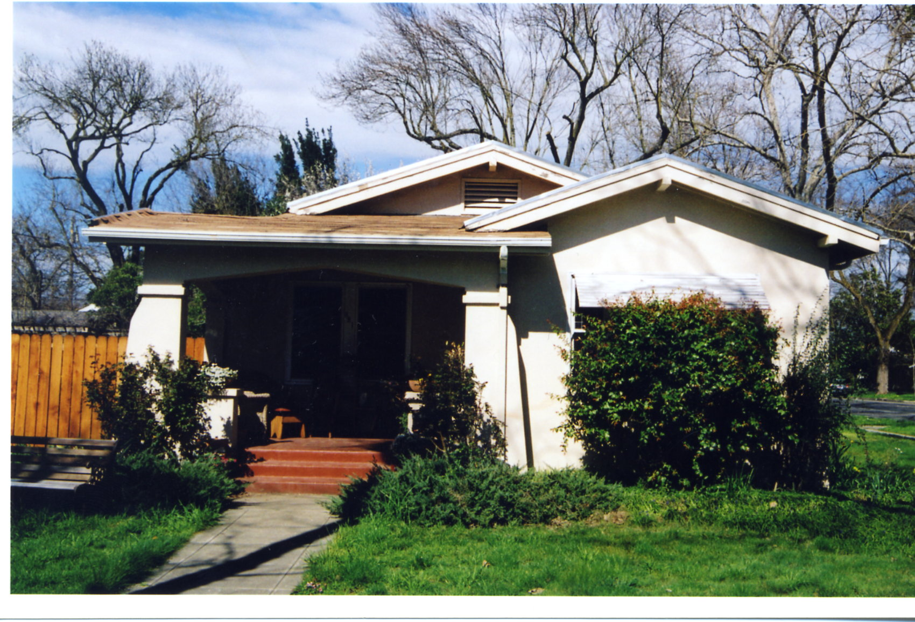
Norris Wilson Trust
641 Amherst Dr
Davis, CA 95616
*P8. Recorded by:
Carol Roland
Roland-Nawi Associates
4829 Crestwood Way
Sacramento, CA 95822
*P9. Date Recorded: 04/07-10/2003
*P10. Type of Survey:  Intensive
□ Reconnaissance □ Other
Describe: Determination of
Local District Eligibility
*P11. Report Citation: none
*Attachments: □ NONE □ Map Sheet □ Continuation Sheet  Building, Structure, and Object Record □ Linear Resource Record □ Archaeological Record □ District Record □ Milling Station Record □ Rock Art Record
□ Artifact Record □ Photograph Record □ Other (List):

